

**BDAT 1008 – DATA COLLECTION AND CURATION**

**FINAL PROJECT**

**BUSINESS REQUIREMENT DOCUMENT**

***Group Number: 10***

***Team Members:***

**Abdul-Baatinul-Haad Yusuf**

**Athul Verghese**

**Milind Satishkumar Tank**

**Deepak Thalian**

Table of Contents

**Purpose of Project** 3

**About Dataset** 3

**Project Use Case** 4

General User Role 4

Administrator Role 4

Use Case Diagram 4

**Business Cases / Questions** 5

# **Purpose of Project**

This group has undertaken this project to enlighten the masses in Toronto, Canada about past, present, and future rates of crime around them. With this project, we will showcase visuals about the types of crime that usually occur and the rates at which they occur. The project will be made available to the masses on a hosted website. This will enable current, and potential people looking to stay in Toronto, view the safest areas. It may also serve as an aid to the Government or police forces to pay attention to hot zones of various crimes and prepare themselves to handle any sudden reports.

# **About Dataset**

“The dataset includes all Major Crime Indicators occurrences by reported date and related offence from 2014 – 2021.

The Major Crime Indicators categories include Assault, Break and Enter, Auto Theft, Robbery, and Theft Over. Excludes Sexual Violence.

This data is provided at the offence and/or victim level, therefore one occurrence number may have rows of data associated to the various MCIs used to categorize the occurrence.

This data does not include occurrences that have been deemed unfounded. Unfounded, according to Statistics Canada means “It has been determined through police investigation that the offence reported did not occur, nor was it attempted” (Statistics Canada, 2020) **

The dataset is intended to provide communities with information regarding public safety and awareness. The data supplied to the Toronto Police Service by the reporting parties is preliminary and may not have been fully verified at the time of publishing the dataset.

The locations of crime occurrences have been deliberately offset to the nearest road intersection node to protect the privacy of parties involved in the occurrence. All location data must be considered as an approximate location of the occurrence and users are advised not to interpret any of these locations as related to a specific address or individual.” (Toronto Police Service, 2022) **

Link to dataset - <https://data.torontopolice.on.ca/datasets/TorontoPS::major-crime-indicators-1/explore?location=20.514081%2C-40.019598%2C4.81&showTable=true>

# **Project Use Case**

There are two main actors in this project, the general users, and the admins.

## General User Role

* View Home Page of website (Including description about dataset)
* View Subsequent pages with visualizations
* View About and Information page (Info about where dataset was gotten, admins, etc.)

## Administrator Role

* View and Update Home Page of website (Including description about dataset)
* View, Update, Create, and Delete Subsequent pages with visualizations
* Update dataset.
* View and Update About and Information page (Info about where dataset was gotten, admins, etc.)

## Use Case Diagram

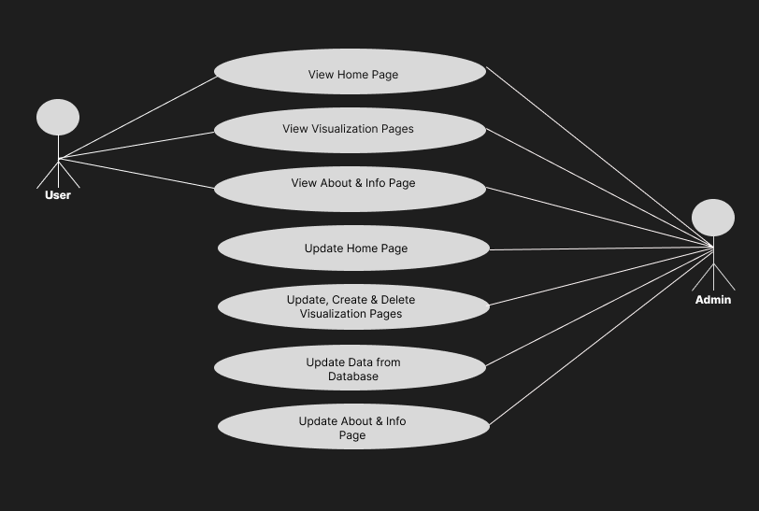

# **Business Cases / Questions**

1. Which Major Crime Indicators occur the most and the least?
2. Which top 10 Neighbourhoods has the highest occurrence for crimes?
3. What year has seen the highest number of MCIs?
4. What Premises type has the highest and lowest occurrence of crimes?
5. Which top 10 Neighbourhoods has the highest occurrence for crimes based on the MCIs?
6. What Premises type has the highest and lowest occurrence of crimes based on the MCIs?
7. A map showing the Neighbourhoods and the total crime occurrences based on premises type.